Machine Learning

# **Name: Pradeep Kumar Gupta**

# **Regno: BL.EN. U4CSE21163**

Lab Assignment 1

**Report**

1. **Discuss the importance of the rank of an observation matrix in model building for classification.**

The rank of an observation matrix often called the feature matrix, is crucial in classification models. It represents the maximum number of independent rows or columns in the matrix. In classification, this matrix has samples as rows and features as columns, describing each sample's attributes.

Matrix rank impacts model complexity, generalization, regularization, and overall classification success. Dealing with multicollinearity, handling dimensionality, and making informed feature selection decisions all depend on understanding and managing the matrix's rank during model development.

As we can observe from the given Purchase Data, we find the dimensionality of the vector space as well as rank i.e. (10, 3) and 3 respectively.

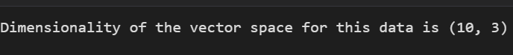

1. **Discuss regression (Ex: A2) and classification (Ex: A3) tasks. How would you differentiate between them?**

* In Ex: A2 we are calculating the model vector X for predicting the cost of the products available for a vendor For example in this case we came to know that the cost of a candy, mango, and milk packet are 1, 55, and 18 respectively.

Whereas In Ex: A3 we categorize the customers into two classes i.e. Rich and Poor. Their classification is based upon the limit i.e. if the payment of the customers is above Rs200 then classified as Rich and if less than Rs 200 then classified as Poor. As a result, we came to know that among 10 customers 6 were classified as Rich, and 4 were classified as Poor.

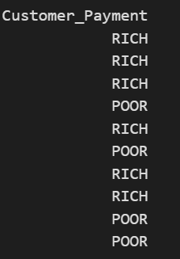

1. **Observing the stock data provided, record your suggestions to build a system that may be able to predict the price and Change % in the future.**

=>To build a system for predicting stock prices and percentage changes in the future:

1. We can collect and clean historical stock price data, including related factors like economic indicators and news sentiment.
2. We can create relevant features and consider lag features from the data.
3. We can split the dataset into training, validation, and test sets.
4. We can experiment with various machine learning models and time series forecasting methods.
5. We can optimize model performance by tuning hyperparameters.
6. We can analyze time-dependent patterns in the data.
7. We can identify key features affecting stock prices.
8. We can use appropriate metrics to assess model performance.
9. We can implement risk mitigation strategies.
10. We can regularly update and retrain the model.